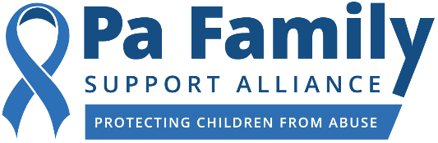

Contact: Caitlin O’Connor, for PFSA Cell: 412-719-5366
Caitlin@ceislermedia.com
*** MEDIA ADVISORY ***

Pa Family Support Alliance to Host a VIRTUAL
Child Abuse Prevention Symposium
Day-long seminar where professionals will come together to receive child abuse prevention training

WHAT: The PA Family Support Alliance (PFSA), a nonprofit organization that is widely recognized as the leading expert on child protection and child abuse prevention in the state, will host a virtual Child Abuse Prevention Symposium. PFSA will have state and nationally recognized experts who will present sessions on key child abuse prevention topics, in an effort to better equip our professionals and volunteers who work with children. The COVID-19 pandemic has impacted everyone, including our children. PFSA is making a deliberate effort to ensure that professionals working with children are prepared for the challenges that come with living, working, and attending school virtually.

WHEN: Thursday, November 5, 2020
9 am – 4 pm

WHO/AGENDA: 9 am-9:15am, Introductions

9:15 am-10:45am, Keynote Speaker (ErinGruwell from Freedom Writers)
- Erin Gruwell is a teacher, an education activist, and the founder of the Freedom Writers Foundation. She created the Freedom Writer Methods, a progressive teaching philosophy and curricula designed to achieve excellence from all students. Erin will share her motivational story, as portrayed in the book, The Freedom Writers Diary: How a Teacher and 150 Teens Used Writing to Change Themselves and the World Around Them.

10:45 am-11am, Morning Break

11 am-12pm, Keynote Speaker Continued (Freedom Writers)

Noon-12:30pm, Lunch

12:30 pm-2pm, First Breakout Sessions

2pm-2:15pm, Afternoon Break

2:15pm-3:45pm, Second Breakout Sessions

3:45pm-4pm, Conclusion

WHERE: There are a few minor, specific steps that need to be taken in order to have virtual access to the symposium. If you or someone from your media outlet is interested in attending, please contact training@pa-fsa.org and you will be provided with the instructions. Note that while all of our speakers are available for media interviews, some do not want to have their actual presentations recorded. Therefore, if you are interested in interviewing or speaking with one of our presenters, please include that information in your email.

###

