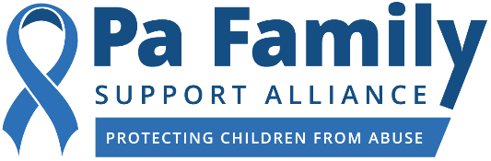

FOR IMMEDIATE RELEASE
April 22, 2021 Caitlin O'Connor, for PFSA
Caitlin@ceislermedia.com
412-719-5366 (cell)

Local Chester County Resident Receives
Blue-Ribbon Champion for Safe Kids Award
The award is given to individuals who have gone above and beyond the call of duty to protect children

Harrisburg, Pa. – The Pa Family Support Alliance, the state’s leader in child abuse prevention, has awarded Leslie Holt with the Blue-Ribbon Champion for Safe Kids Award. This award is given to five Pennsylvanians who have gone above and beyond the call of duty to support and protect Pennsylvania’s children.

Leslie Holt is the founder and director of A Child’s Light, a non-profit organization that funds the access of mental health treatment for children who have been the victims of sexual assault or have experienced domestic abuse. The organization supports Chester County children and adolescents between the ages of 2-18 years old. Holt is a vocal advocate for children. She has made it her life’s work to ensure that children who are abused receive the necessary resources that help them charter a path towards recovery and healing.

Additionally, Holt is one of the co-creators of The RADAR Project, which is a database that allows victims of sexual assault and domestic abuse to record on a map where their abuse occurred. It provides them with a safe space online to share their personal stories.

“Leslie has been a fierce and tireless advocate for Pennsylvania’s children,” said Angela Liddle, President and CEO of the Pa Family Support Alliance. “She understands that when abuse is perpetrated against children, the impact can be often unseen—that is why she works to get them the support programs and clinical services they need. Leslie personifies what it means to be a champion for children.”

In honor of this accomplishment, the Pa Family Support Alliance is debuting a video on its Facebook page today which will feature Holt receiving the award. The video can be found here. Normally, the Pa Family Support Alliance hosts a ceremony in the Capitol rotunda in Harrisburg to honor its Blue-Ribbon Champion recipients. But, due to the ongoing COVID-19 pandemic, the organization is sponsoring a virtual month-long awareness campaign to honor the Blue-Ribbon Champions and generate awareness about ways we can all work together to prevent and report child abuse.

As part of the month-long awareness campaign, the Pa Family Support Alliance will debut video messages and photos featuring the Department of Human Services Secretary Teresa Miller and Deputy Secretary Jonathan Rubin, Attorney General Josh Shapiro, Secretary of Education Noe Ortega, Second Lady Gisele Fetterman, State Senators Judy Ward and Maria Collett as well as State Representatives Sheryl Delozier and Pamela DeLissio. In Secretary Miller’s video, she announced the Blue-Ribbon Champions recipients and thanked Holt for her steadfast commitment to supporting Harrisburg area children. That video can be found here.

###
About Pennsylvania Family Support Alliance
Pa Family Support Alliance prevents child abuse and protects children from harm by helping parents learn positive parenting techniques, educating professionals and volunteers who work with children to recognize and report child abuse, and helping community members learn how they can play a positive role in keeping children safe. To learn more about our programs, schedule a training, or donate, please visit pa-fsa.org, or call 800-448-4906.

